**MATEMATIKA, 2. RAZRED 21.12.2020**

**NARAVNA ŠTEVILA DO 5 – ŠTEVILA DO 5**

KLIKNI NA SPODNJO POVEZAVO IN SE IGRAJ.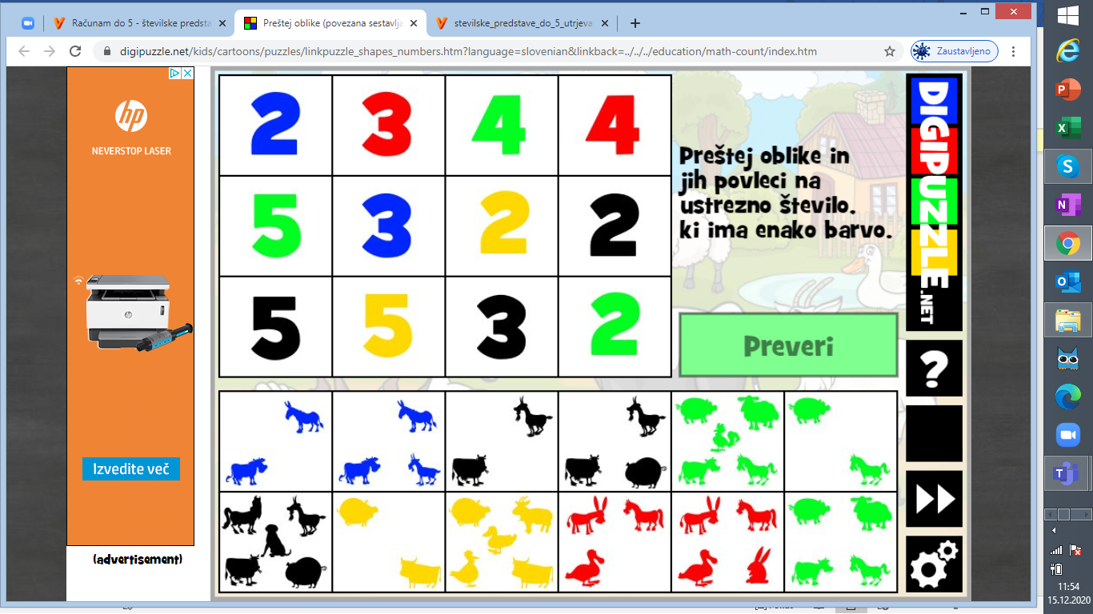

<https://www.digipuzzle.net/kids/cartoons/puzzles/linkpuzzle_shapes_numbers.htm?language=slovenian&linkback=../../../education/math-count/index.htm>

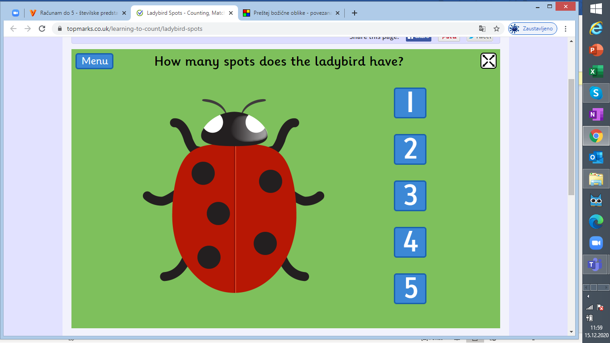

<https://www.topmarks.co.uk/learning-to-count/ladybird-spots>

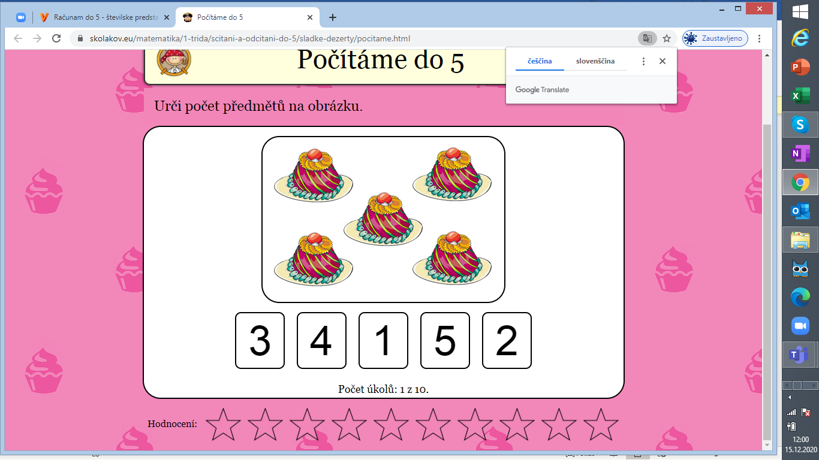

https://skolakov.eu/matematika/1-trida/scitani-a-odcitani-do-5/sladke-dezerty/pocitame.html